REST stands for Representational state transfer, which means that it defines a programming architecture that uses the HTTP Methods (GET/POST/DELETE/PUT).

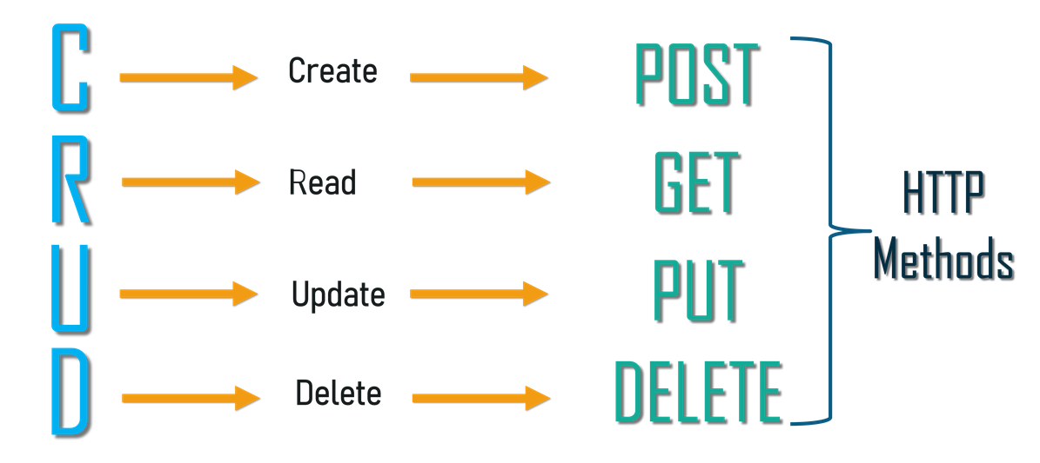

Example of REST API: For an Example of E-commerce, where they are connected with multiple customers, and whenever anyone do transaction details would be updated.

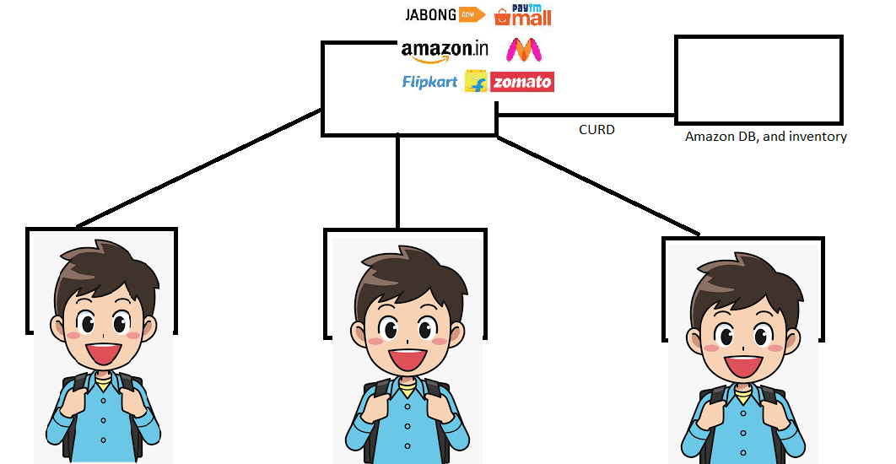

REST API FLOW Chart:

